**Name:** sherif hesham taher abd el manam

**B.N:** 417

**Date:** 30/5/2020

**Topic:** Programming language

**Github link:** <https://github.com/shrief-hesham/programming-languages>

**Github page:**  <https://shrief-hesham.github.io/programming-languages/>

**Application brief:**

A programming language is a formal language comprising a set of instructions that produce various kinds of output. Programming languages are used in computer programming to implement algorithms. Most programming languages consist of instructions for computers. There are programmable machines that use a set of specific instructions, rather than general programming languages. Early ones preceded the invention of the digital computer, the first probably being the automatic flute player described in the 9th century by the brothers Musa in Baghdad, during the Islamic Golden Age. Since the early 1800s, programs have been used to direct the behavior of machines such as Jacquard looms, music boxes and player pianos. The programs for these machines (such as a player piano's scrolls) did not produce different behavior in response to different inputs or conditions.

**Some applications:**

1.C

2.C#

3.C++

4.CSS

5.HTML

6.Java

7.JavaScript

8.Objective-C

9.PHP

10.Perl

11.Python

12.Ruby

13.SQL

14.Swift

**Screenshots:**

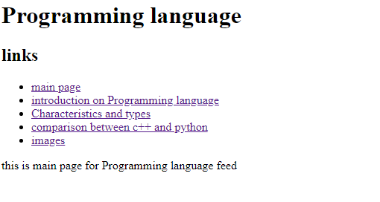

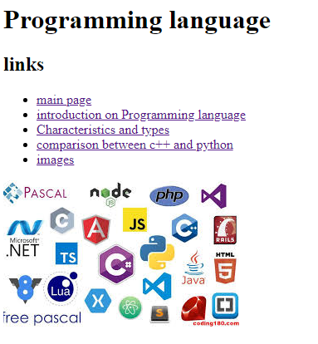

**Source code:**

